**TRANSLATION REQUEST PROCESS**

AFTER YOU RECEIVE THE JIRA NOTIFICATION

1. Drag and drop the spreadsheet from task to desktop. Add the the task number at the beginning of the file name: "SPDF-1234 -PO name". (e.g. SPDF-1234-Kevin Gavin)
2. Check the order of the request languages in spreadsheet: EN FR DE IT ES PT RU SV VI ID JA (languages must be written in this order).
3. Put anything that you don’t want translated in red, i.e. Soda PDF, E-Sign, OCR, MS Word. Recheck requested languages:

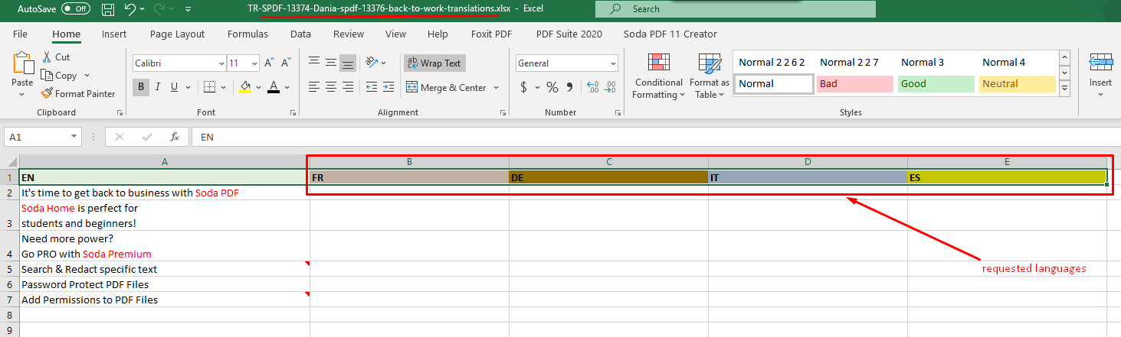

1. Send email to translations agency.
   1. Your main contact at Rossion will be Alex Guilbault ([alex@rossion.com](mailto:alex@rossion.com)).
   2. Always CC Federico Buchbinder ([federico@rossion.com](mailto:federico@rossion.com)) and Lisa Tosques ([lisa@rossion.com](mailto:lisa@rossion.com)), who are also project managers at Rossion who help us out when Alex isn’t available.
   3. The subject must be written in the format shown below:
      1. Translation Request – Task #- PO name- Required Languages

*Note: To understand who is the PO of a particular task, first of all look who is reporter of the task:*

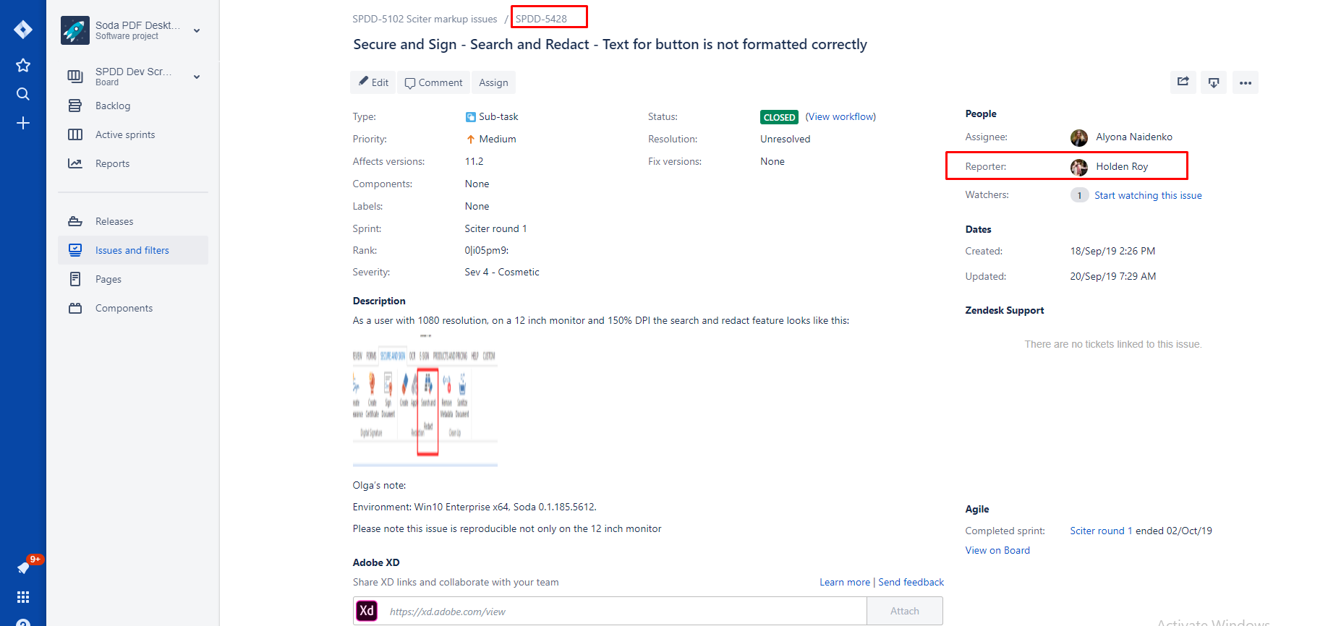

**The POs in Montreal**: Cesar, Alvaro, Mazen, James, Kevin, Ian, Chrissy, Pete, Dimitri, Linsay, Lyes, Swanee, Simona, Dania or Holden.

If you receive the translation request from ouroffice, you can ask **Natalia Eltsova, Olha Rudenok** (our project managers) who should be mentioned as PO for your translation request.

Example:

To: alex@rossion.com

CC: federico@rossion.com; lisa@rossion.com

Subject: Translation request - SPDF 5891-Dimitri - FR, DE, IT, ES, PT, JA

Body: Hello, Please have the attached file translated and delivered by Thursday if possible. Thanks!

1. Delivery Time
   1. The standard time for translations is 2 days. So, if you receive a request on Tuesday, it will be delivered on Thursday.
   2. For urgent requests: write "URGENT -" in subject and ask if it can be delivered the next day.
      1. If not possible, ask for delivery on the second day but in the morning.
   3. Longer projects may require more time. If that’s the case, the agency will tell you how much time they need.
   4. Also please add the screenshot in your translation request if needed (for more context) -> see example on the screenshot below:

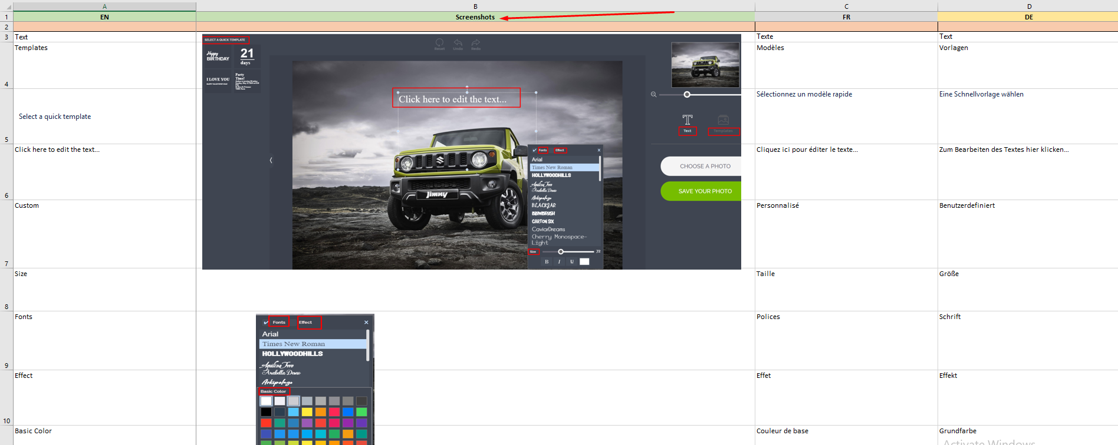

1. Attach the spreadsheet to the email
   1. If needed, the translators may ask you for screenshots or context later on.
2. Update Jira
   1. Start Development in **Jira** after you send the email
   2. & add a comment with the ETA and tag the PO or the person who asked for translation. [Ex. @Natalia, translations should be back by Tuesday.]
3. Drag the spreadsheet to the **Translations** folder (<https://lulusoftware1-my.sharepoint.com/personal/admin_lulusoftware_com/Documents/Translations>)
4. Put it in the correct folder depending on the task (it means the request was sent but has not been received).
   1. Development - In-App or Desktop Settings requests
   2. Marketing -
   3. SEO -
   4. PPC & Email -
   5. Support –
5. Open Contacts & Tracker Excel file
6. a. Add entry in the document **Contacts & Tracke**r (as pending). This helps you keep track of all translation tasks.
   1. Open - Edit
   2. Copy & paste line
   3. Change info
   4. Save

AFTER YOU RECEIVE THE COMPLETE TRANSLATIONS

1. Confirm to Alex that you got it: Hey Alex, Confirming safe receipt.”
2. Check the document to make sure all translations are there.
3. Drag to desktop the file to the desktop and add to the name "Complete -".
4. Drag to the task to Jira
   1. ; add a comment and re-assign to PO. [Ex. @Simona Nocella translations attached.]
5. Fill in **Contacts & Tracker** document's last 3 columns (in Translations folder).
   1. Edit - received
   2. Mark as "completed & Delivered"
   3. Save
6. Translations Folder
7. Go to the **Translations** folder (<https://lulusoftware1-my.sharepoint.com/personal/admin_lulusoftware_com/Documents/Translations>)
   1. Delete "pending" spreadsheet and drag the completed version to the “Delivered” file.
8. Make a Desktop copy of the **Translations** folder (so that you can search for a string quickly if a PO asks you to).